Appendix A. Spatial transfer of origin and destination attributes to the line layer representing the network of street segments
This Appendix is related to the article “Urban core-periphery structure: exploration of an emergent phenomenon”. It details the procedure used to transfer polygon-based socio-spatial attributes to the street-segment network. Two different source layers were used: (a) census tracts, representing residential origins, and (b) hexagonal cells, representing employment destinations. In both cases, the transfer was based on segment influence areas derived from a Voronoi tessellation associated with the street network.

Appendix A.1. Creation of street-segment influence areas
The steps described in Table A1. illustrate the procedures taken to create the influence areas for street segments.
Table A1. Procedures utilized to create influence areas of street segments.
Step | Description | Illustration
1 | To construct segment-based influence areas, we first generated points at both ends of every street segment.  Duplicate points were then removed. | 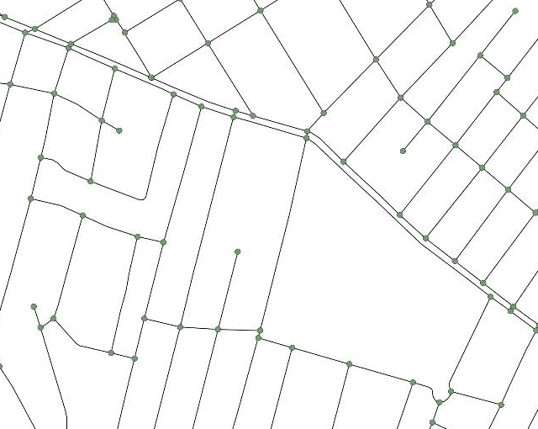
2 | Around the remaining points, a 1 m buffer was created and used to trim the street segments,... | 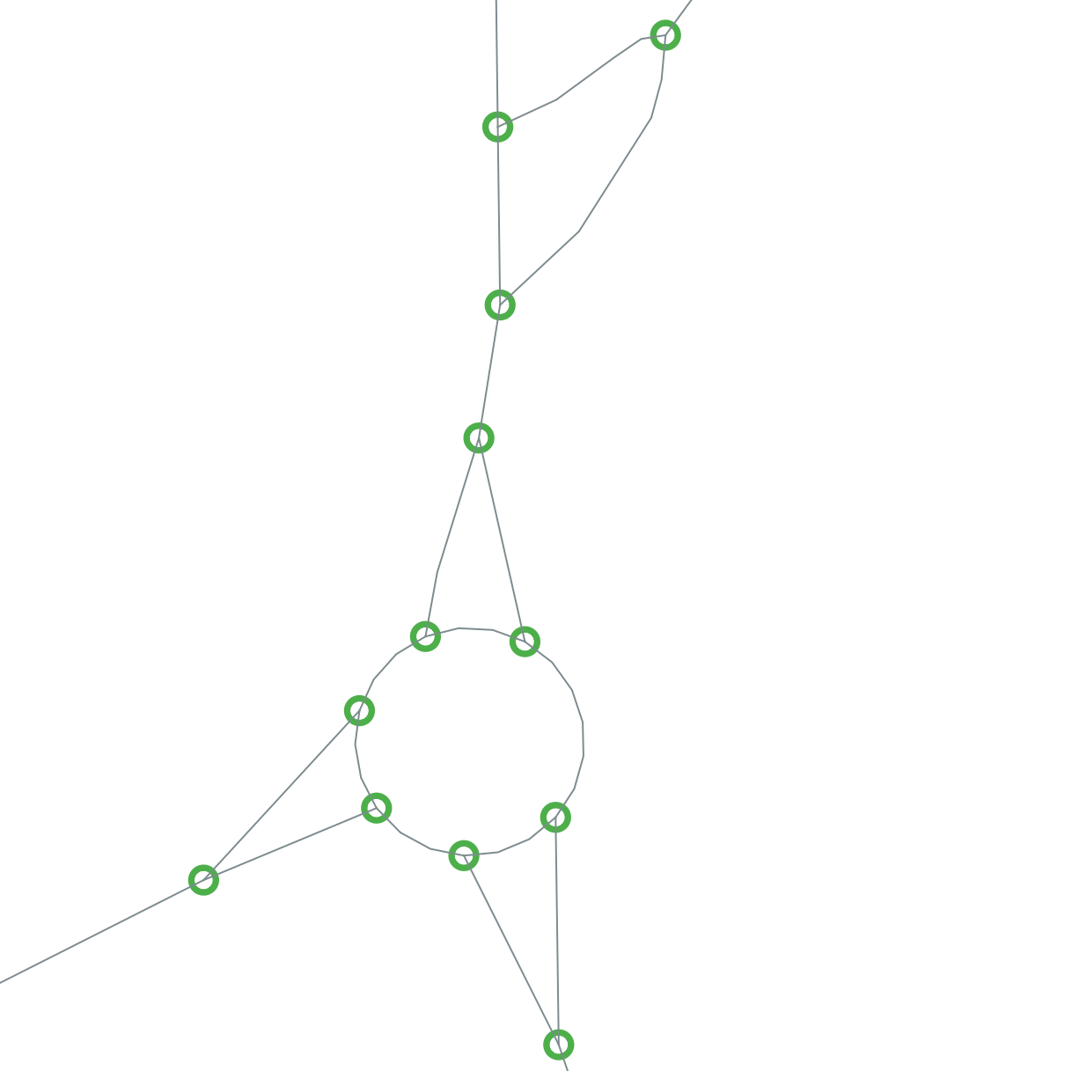
3 | …so that adjacent segments would no longer touch at intersections. | 
4 | Segments shorter than 5 m after trimming were excluded, as these mostly corresponded to residual or analytically uninformative fragments, such as small roundabout pieces. | 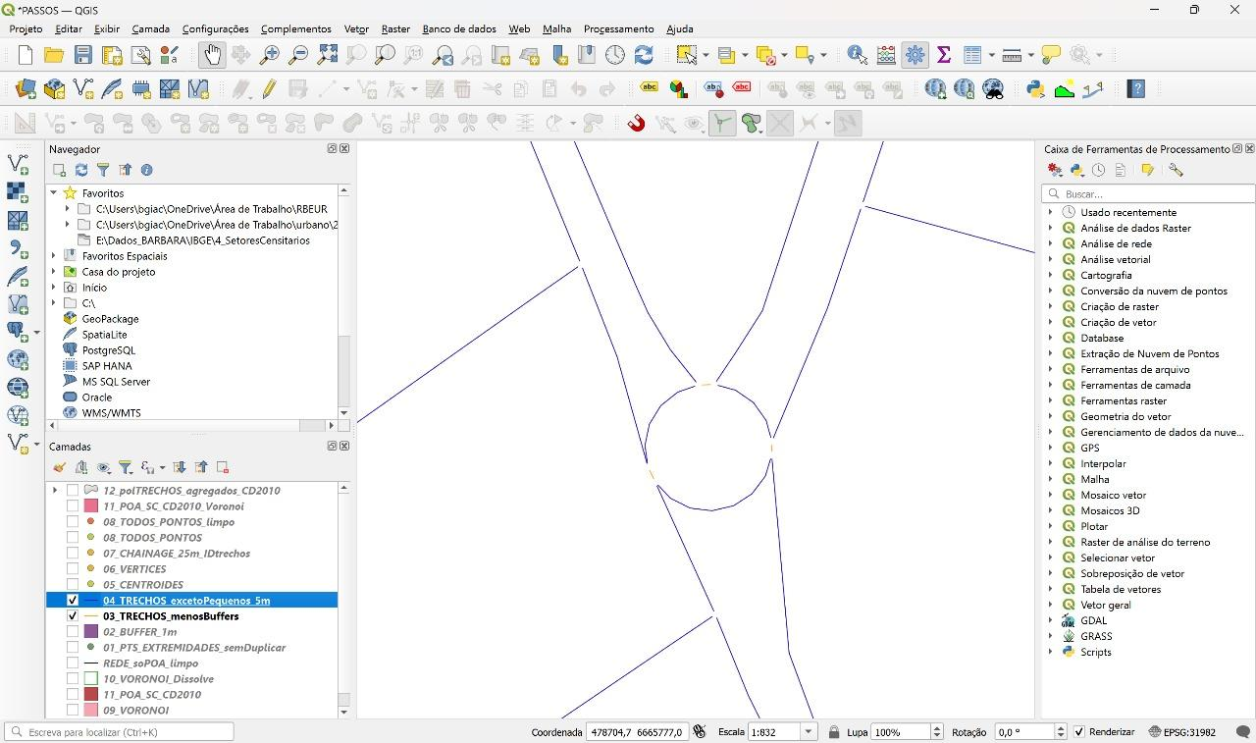
5 | From the resulting trimmed segments, a dense set of representative points was generated, including points spaced every 25 m along each segment, as well as centroid, first-point, and last-point locations.  Duplicate points were again removed. | 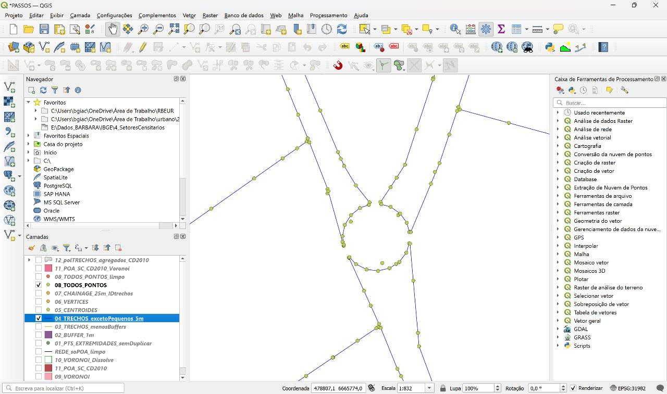
6 | A planar Voronoi diagram was then created from this point set. | 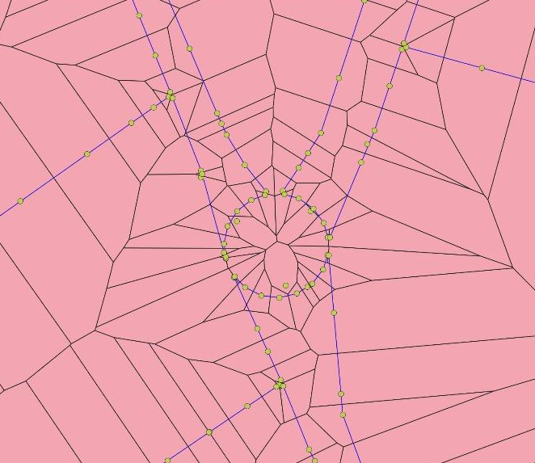
7 | Finally, the Voronoi polygons were dissolved according to the unique segment identifier (segment_ID), producing one influence polygon for each street segment. These dissolved polygons represent the segment influence areas used in the subsequent spatial allocation procedures. | 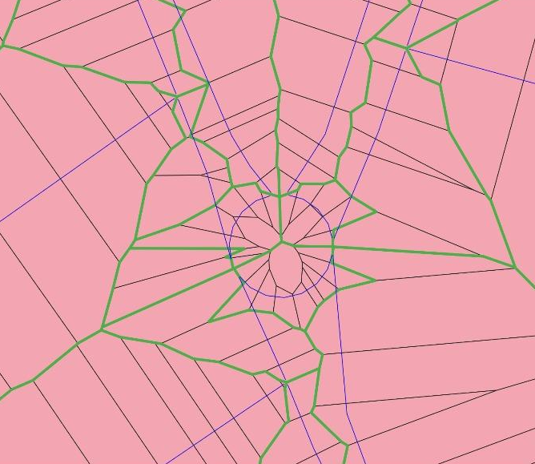

Appendix A.2. Transfer of population attributes from census tracts to street segments
The steps described in Table A2. illustrate the procedures taken to transfer population attributes from census tracts [1] to street segments.
Table A2. Procedures utilized to transfer population data to the street segments.
Step | Description | Illustration
1 | For residential origins, the census-tract polygons were clipped by the dissolved Voronoi polygons representing the street-segment influence areas.  For each resulting polygon fragment, the proportional share of census attributes was calculated according to the ratio between the fragment area and the original census-tract area. | 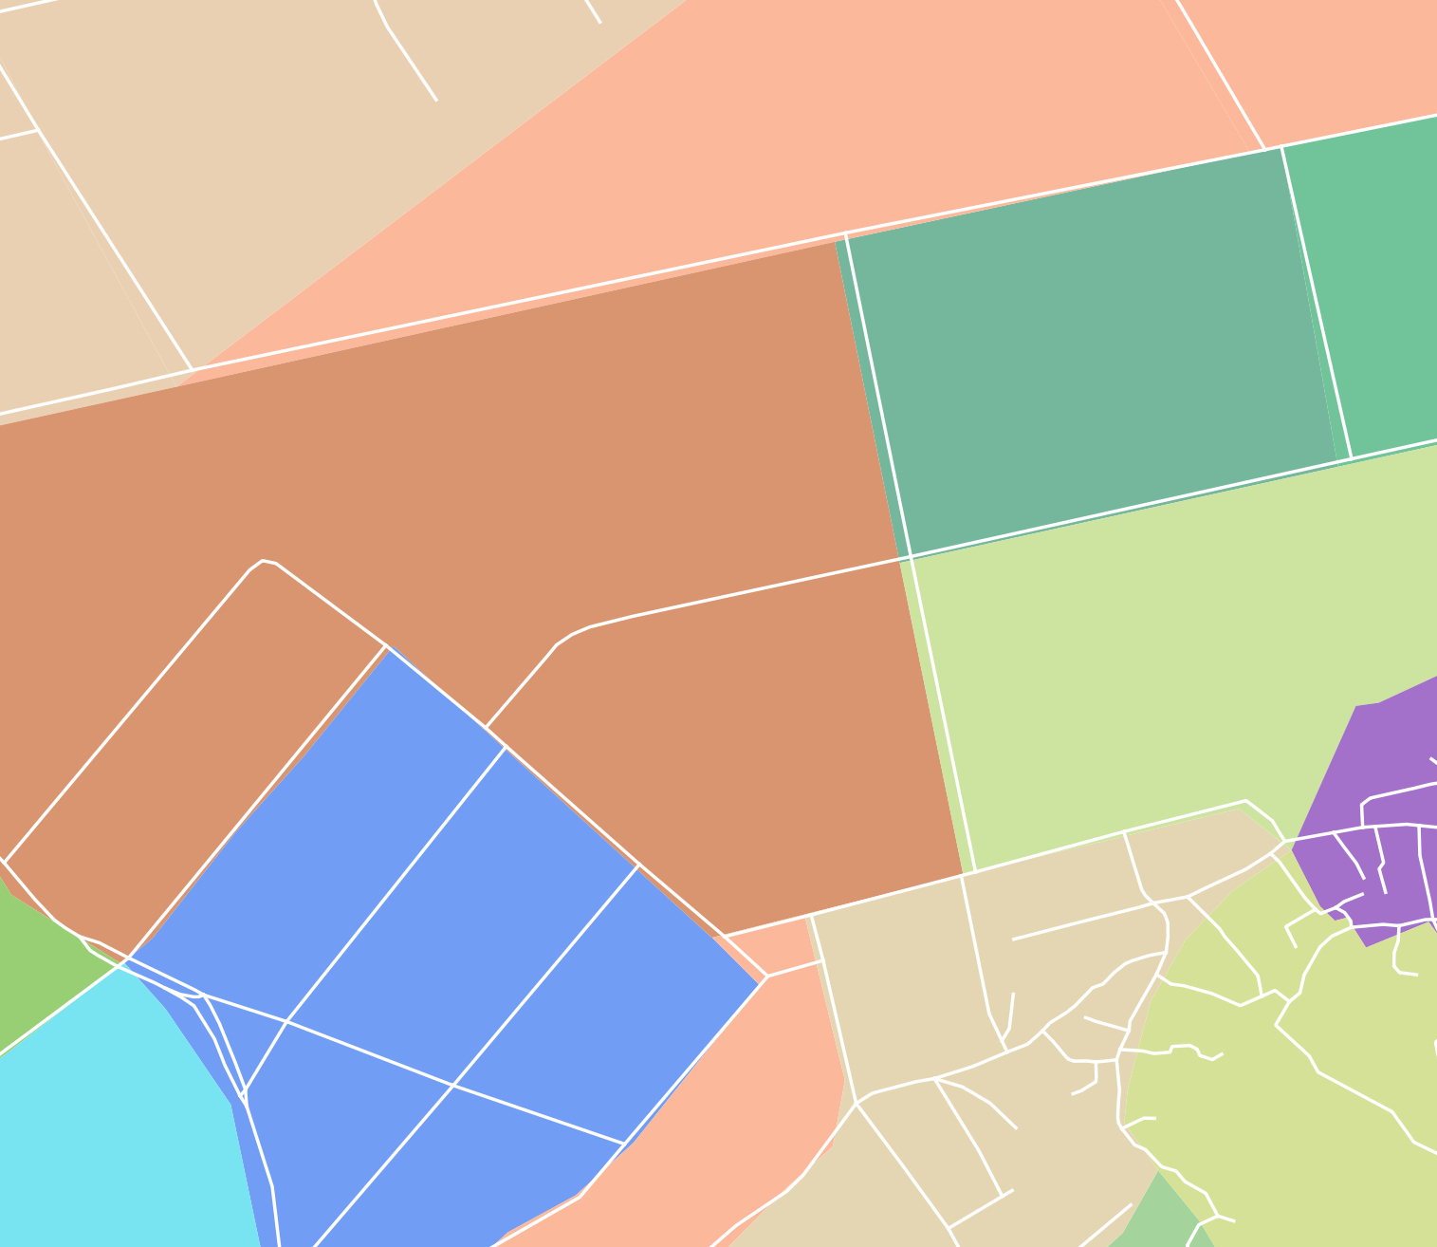  Census tracts (colored polygons)  Street segments (white lines)  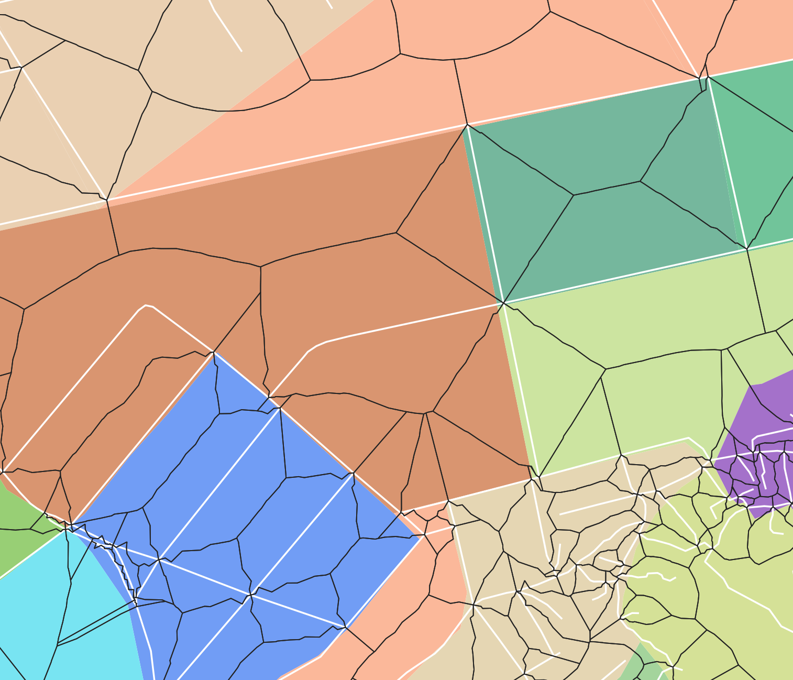  Street segments influence areas (black lines)  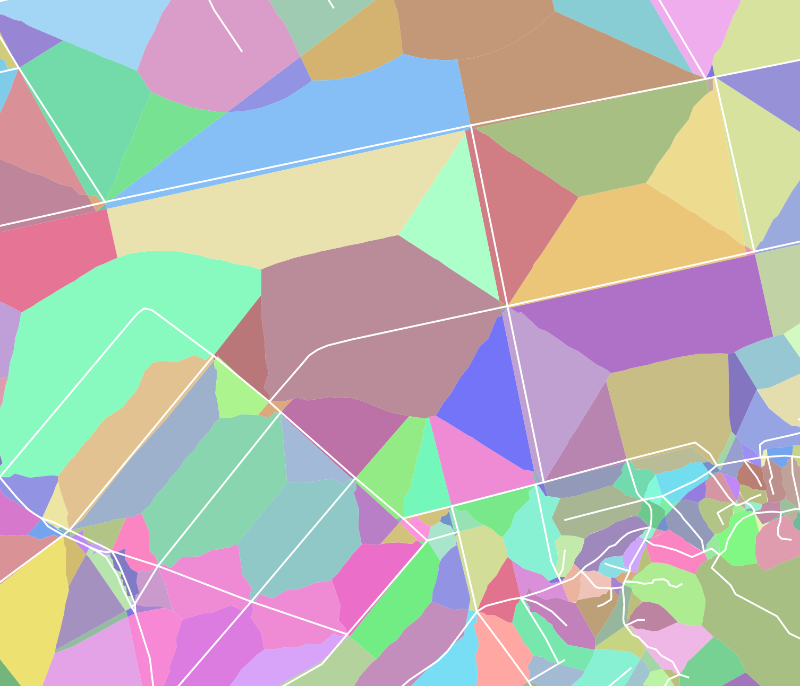  Census tracts clipped by Voronoi polygons (colored polygons)
2 | The clipped fragments were then dissolved by the segment ID, so that the apportioned census values associated with each fragment were aggregated to the corresponding segment. | 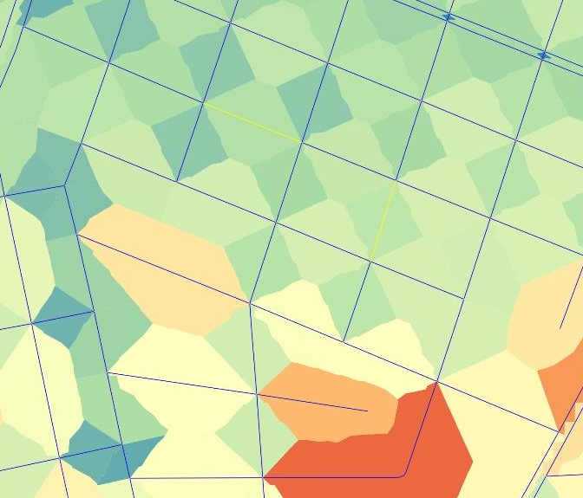
3 | Finally, these attributes were joined to the street-segment layer using the common segment identifier. | 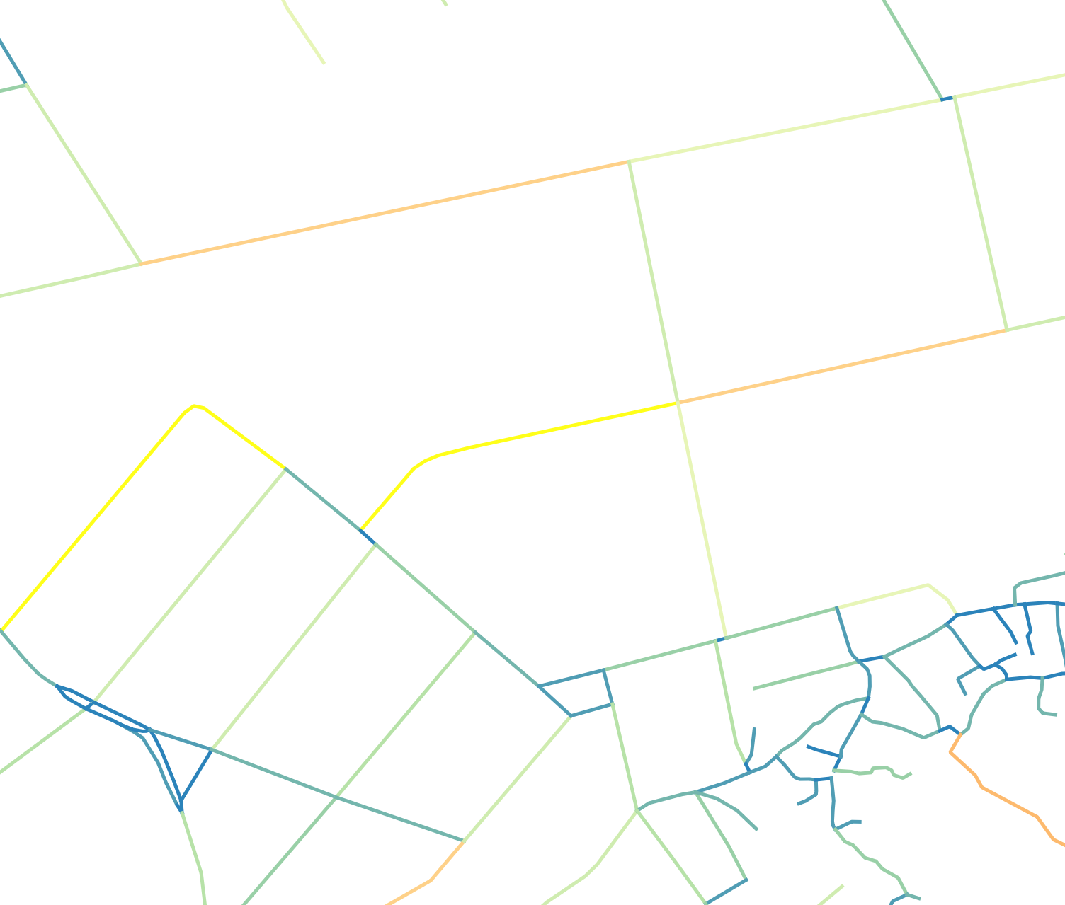

Appendix A.3. Transfer of employment attributes from hexagonal cells to street segments
The steps described in Table A3. illustrate the procedures taken to transfer employment attributes from hexagonal cells to street segments.
Table A3. Procedures utilized to transfer employment data to the street segments.
Step | Description | Illustration
1 | Data for employment from IPEA [2] are aggregated to an hexagonal grid | 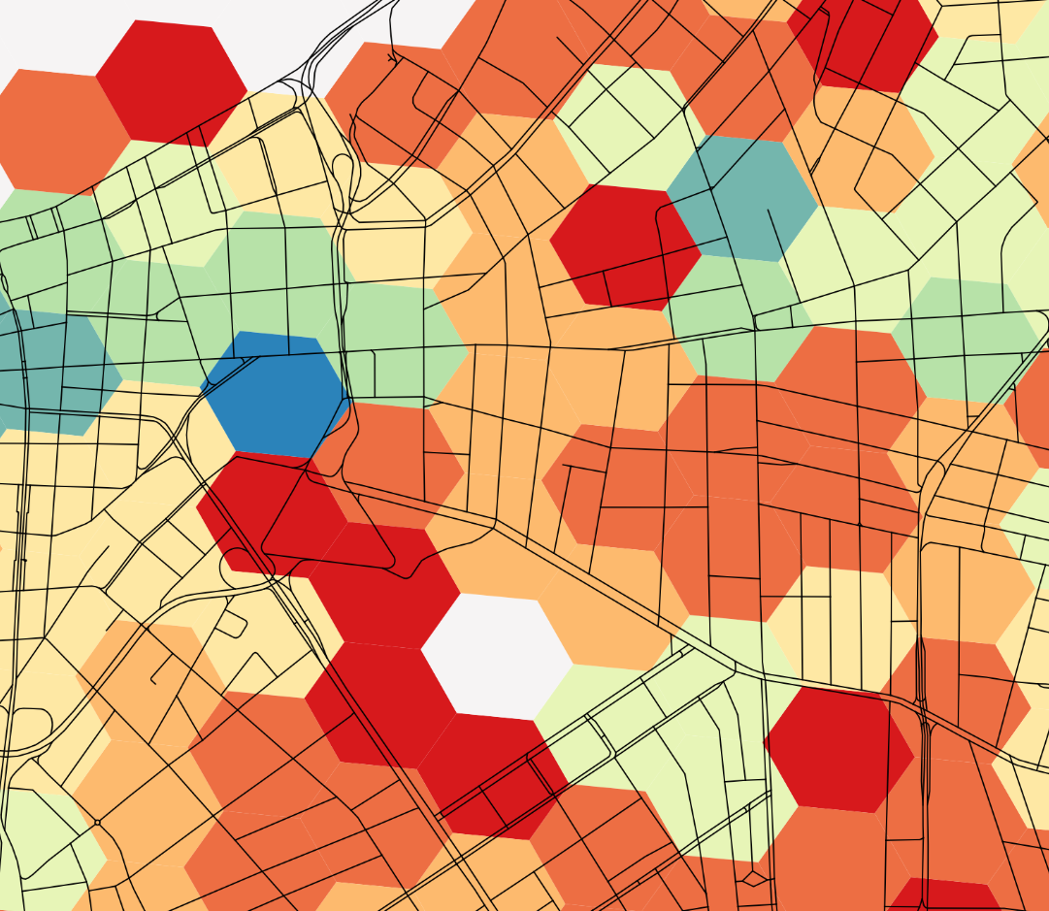
2 | The hexagonal grid was intersected with the dissolved Voronoi polygons representing segment influence areas.  Employment variables were proportionally allocated according to the area relationship between the original hexagon and the intersected fragment. | 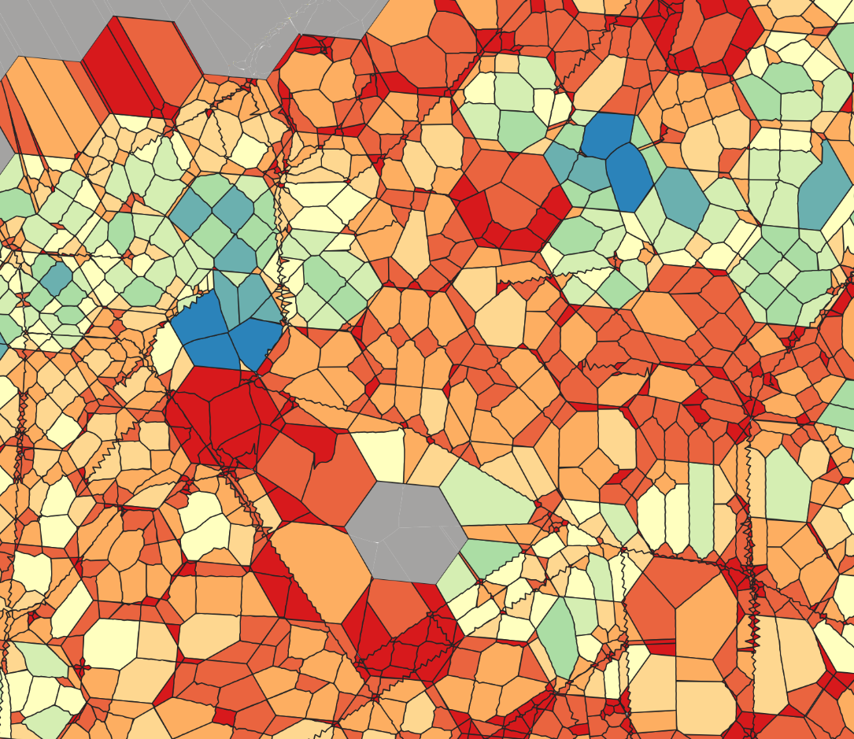
3 | The resulting hexagon fragments were then dissolved by the unique segment ID | 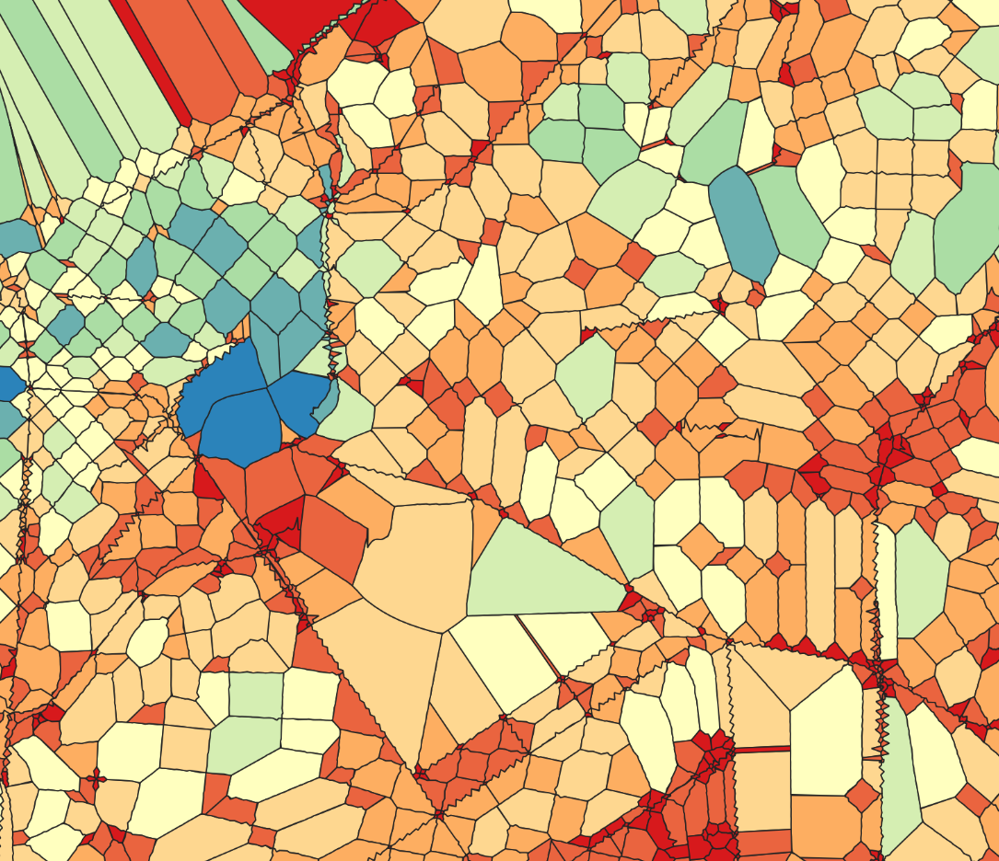
4 | The aggregated employment values were transferred to the street-segment network through this common segment identifier. | 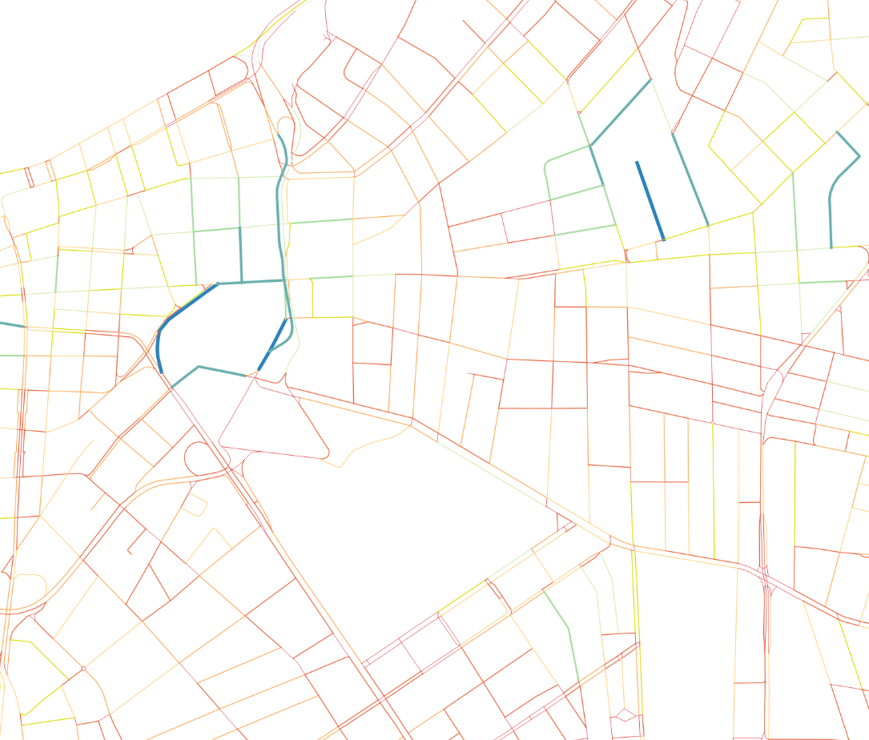
Appendix A.4. Analytical logic
This procedure allowed both residential and employment data, originally available in polygon form and at different spatial supports, to be consistently translated into segment-based attributes. By assigning origins and destinations to street-segment influence areas rather than directly to larger areal units, the method improves compatibility with the subsequent network-based centrality analysis and provides a finer representation of socio-spatial interactions along the street system.
References
- IBGE - Brazilian Institute of Geography and Statistics: 2010 Population Census. Universe results by enumeration area - Characteristics of the population and households. IBGE, Rio de Janeiro (2011). https://censo2010.ibge.gov.br/, last accessed: 2025/11/11.
- Pereira, R. et al.: Spatial distribution of sociodemographic characteristics and location of jobs and public services in the twenty largest cities in Brazil. IPEA Discussion Paper, 2772 (2022). http://repositorio.ipea.gov.br/handle/11058/11225, last accessed: 2025/11/11.

